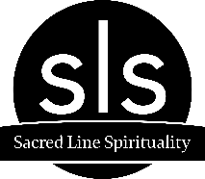

75 Hour Meditation Teacher Training 2023/24 Application

Date:
Name:
Email:
Phone:
Current Occupation:

1 | Please describe your current and past experience with meditation. How long have you been practicing? What style(s) of meditation do you practice? Who are your primary teachers?
 | -
2 | Why do you practice meditation? How has it impacted your life?
 | -
3 | What aspects of this practice are you most interested in?
 | -
4 | What are your intentions and expectations for taking this particular Teacher Training program?
 | -
5 | Do you teach meditation currently? If so, why do you teach? If not, why do you want to become a meditation teacher?
 | -
6 | What do you think your biggest obstacle will be to overcome during this training?
 | -
7 | What are your other interests and hobbies?  -
8 | Please add any other information that you would like to share, or you feel that we should know about you.  -

